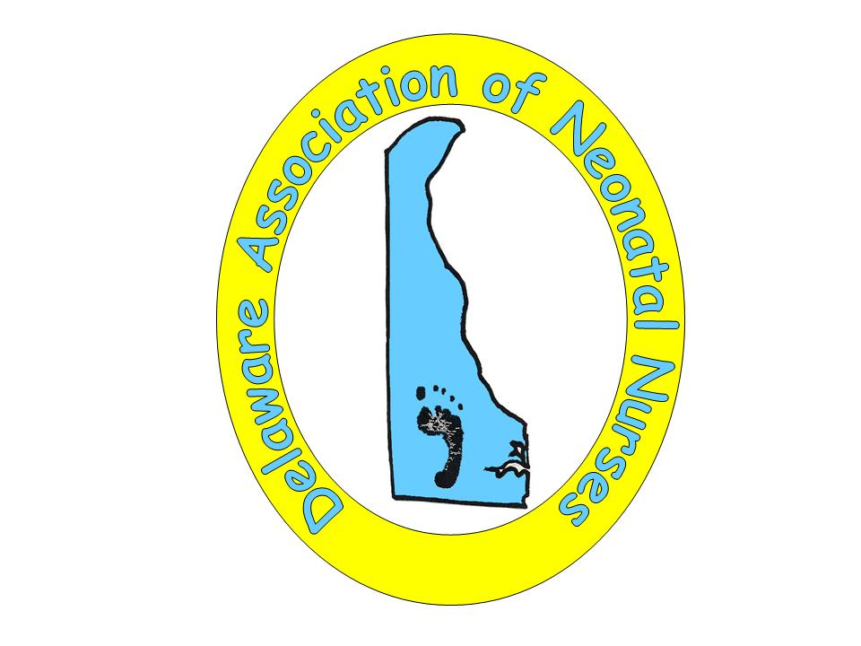
Delaware Association of Neonatal Nurses
Membership Application

LAST NAME ___________________________ FIRST NAME ____________________________

HOME ADDRESS________________________________________________________________

CITY/STATE/ZIP_________________________________________________________________

HOME/CELL PHONE______________________ EMAIL_________________________________

EMPLOYER____________________________________________________________________

POSITION/ TITLE__________________________ WORK PHONE_________________________

NURSING LICENSE NUMBER______________________________________________________

NANN MEMBERSHIP NUMBER / EXPIRATION DATE _____________________________
(NANN MEMBERSHIP IS REQUIRED)

ACADEMIC CREDENTIALS PROFESSIONAL CREDENTIALS
(Check all that apply) (Check all that apply)
□ Nursing diploma □ LPN □ RN
□ Associate, nursing □ RNC- Neonatal nurse, low risk
□ BSN □ MSN □ RNC- Neonatal nurse, high risk
□ PhD □ DnP □ IBCLC □ CNS □ NNP
□ Other____________ □ Other__________________

□ I grant permission for my membership information to be published in the DANN directory, which will only be given to DANN members. This will not be posted on the internet.

□ I am interested in participating on the DANN board and/or subcommittees.

□ I am interested in being a DANN liaison for my unit.

MEMBERSHIP DUES: $20.00 □ New Member □ Renewal
Money order or check payable to: DANN, PO Box 7311, Newark DE, 19714

